**Bug Report**

**Date : 17/12/2024**

**Tested By :** Anil

|  |  |
| --- | --- |
| **Platform** | **Browser** |
| Windows 10 | Chrome |

|  |  |  |
| --- | --- | --- |
| **Who Detected** | **How Detected** | **Status** |
| Quality Assurance | Testing | Open |

|  |  |  |  |  |  |
| --- | --- | --- | --- | --- | --- |
| **Founder** | **Bug Id** | **Type** | **Description** | **Steps** | **Severity/ Priority** |
| Anil | TB_01 | Bug | The user can navigate to the Training section and view the correct content. | 1. Navigate the URl <https://magento.softwaretestingboard.com/>  2. click on the Training link in the the main menu  3. verify the Training section page is display  4. check the content listed in the training section | medium/  medium |
| Anil | TB_02 | Bug | The Sale section displays the correct discount information for products. | 1. Navigate to URl <https://magento.softwaretestingboard.com/>  2. check the products listed in the sale section  3 3. verify that the correct discount information is displayed for each product | High/  High |
| Anil | TB_03 | Bug | The system allows or restricts special characters in the name fields as per validation rules. | 1. Navigate th URl <https://magento.softwaretestingboard.com/>  2.Enter details with special characters in the name fields  3.First Name Enter a name with special characters Last  4.Name Enter a name with special characters Email  5.Address Enter a valid email address Password Enter a valid password | medium/High |
| Anil | TB_04 | Bug | The system allows and restricts numerical in the name fields as per validation rules. | 1. Navigate to URl <https://magento.softwaretestingboard.com/>  2.Enter details with special characters in the name fields  3.First Name Enter a name with special characters Last Name  4.Enter a name with special characters Email Address Enter a valid email address | Major/  medium |
| Anil | TB_05 | Bug | the user can search for products using a valid search query and get accurate results. | 1. Navigate th URl <https://magento.softwaretestingboard.com/>  Enter a valid search query in the search bar  Click the Search button or press  EnterVerify that the search results page displays relevant products. | Major/  medium |
| Anil | TB_06 | Bug | The system displays an appropriate error message when an incorrect address is provided during checkout | 1. Navigate th URl <https://magento.softwaretestingboard.com/>  Navigate to the cart page.  Click on the Proceed to Checkout button  .Enter an incomplete shipping address Enter valid payment details.  Click on the Place Order button.  Verify that the system displays an error message indicating that the address is incomplete. | High/High |
| Anil | TB_07 | Bug | the system displays an appropriate error message when a non-existent address is provided during checkout. | 1. Navigate th URl <https://magento.softwaretestingboard.com/>  Navigate to the cart page.  Click on the Proceed to Checkout button  Enter a non-existent shipping address  Enter valid payment details.  Click on the Place Order button.  Verify that the system displays an error message indicating that the address is non-existent | Medium /High |

Bug ID TB_01

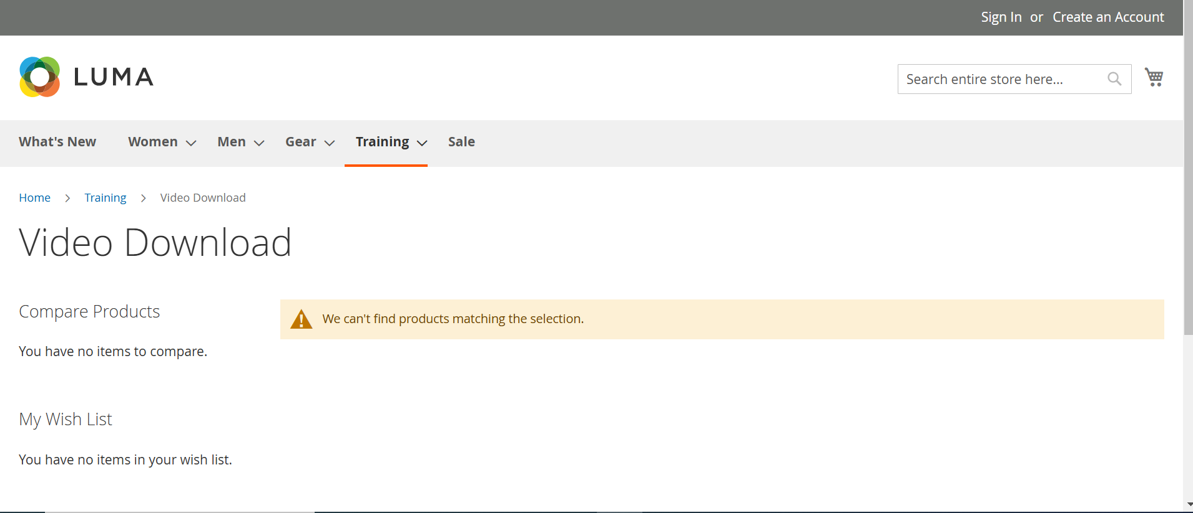

BUG ID- TB_02

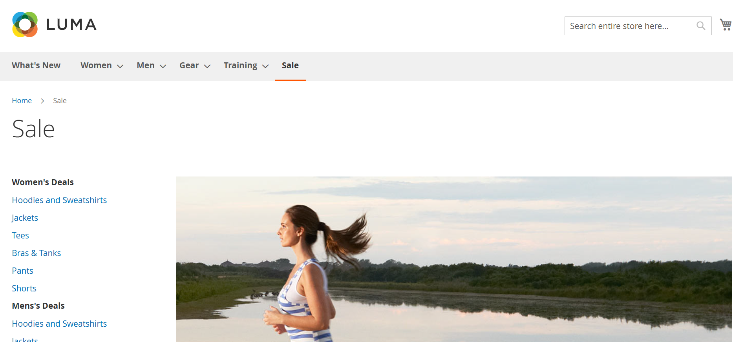

Bug ID – TB _03

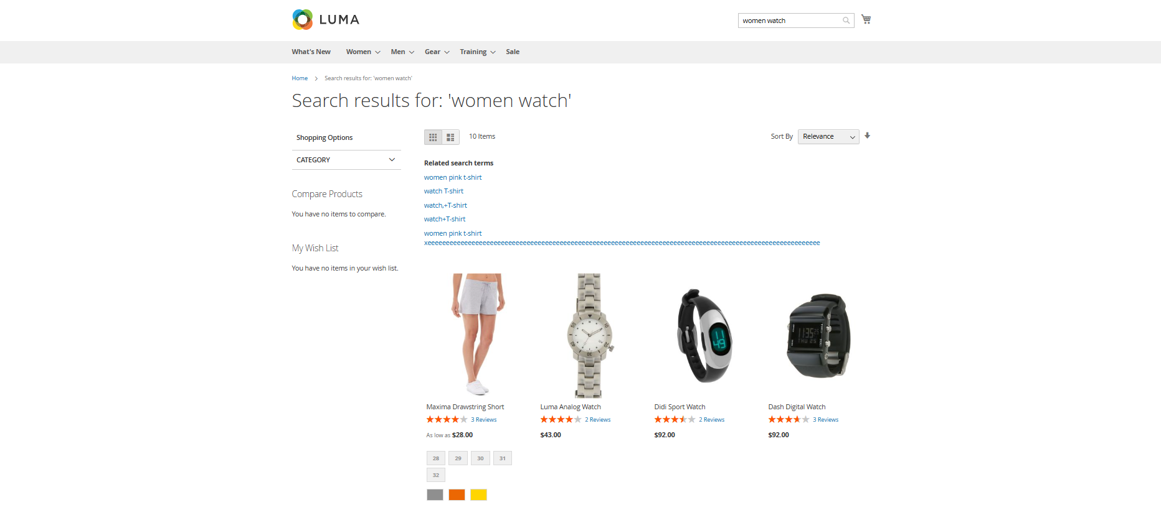

Bug Id _ Tb _04

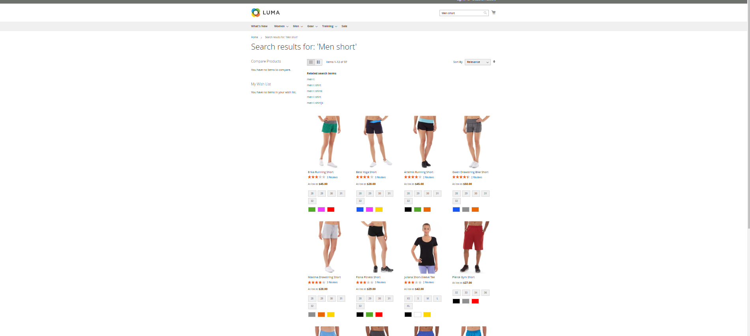

Bug id -TB -05

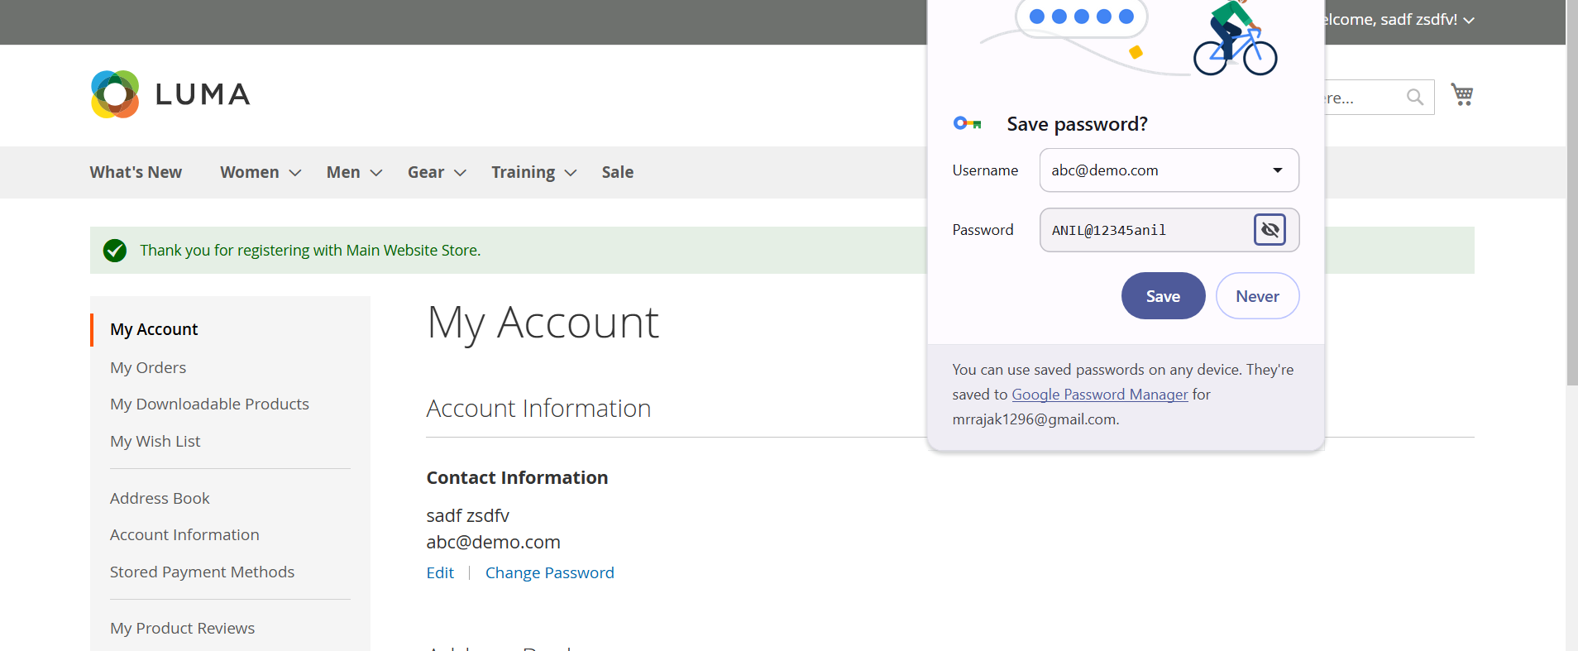

Bug id _ TB_06

